13. Tools for S-BPM

13.1 To Go

|  |  |
| --- | --- |
| We’re making great progress using the method. I think the suite of tools actually helped us very well to describe the models, to try them out, and to implement them. | Tuete_Schleife - Kopie |
|  |  |
| Becher_ohne - Kopie | The validation in particular was so much easier. We could interactively evaluate the various models without endless interviews and theoretical discussions, and without traveling around. |
| Using the specialized tools, it is much simpler to write down what we actually mean. It is so much more tedious with Standard applications for writing and drawing. I especially enjoyed being able to immediately interactively test my specifications. | Tuete_ohne_neu |
|  |  |
| Becher_Krawatte - Kopie | Yes, that does make everything easier and faster. I think that the direct implementation has saved us a lot of time. With the help of the simulation, we were also able to better assess how many resources we need to execute the processes. |
| I think it is important for us to respond quickly to changes in our business environment, and the tools allow us to do so. | Tuete_Schleife - Kopie |
|  |  |
| Becher_Krawatte - Kopie | Speaking for management, we are reassured that everyone knows how they need to work. Compliance is virtually no longer a problem, because the process models are documented seamlessly, and the resulting key performance indicators provide a good overview of the company situation. |
| However, only after we have not only defined the targets, but also clarified further activities for moving forward. For Actors, this would mean that their interventions along the process sequence have been determined. | Tuete_Schleife - Kopie |

In the following sections, we provide insights into jBOOK, jSIM, and the Metasonic Suite, exemplifying a set of tools for each activity bundle in the development process for business process applications. jBOOK is a documentation tool to support subject-oriented analysis. jSIM can be used by Actors to simulate processes based on subject-oriented models on the computer.

The Metasonic Suite consists of a number of elements: The module "Build" supports the modeling of the subjects, their behavior, their interactions, and the thereby exchanged messages and business objects. "Proof" enables distributed, computer-aided validation and "Flow" as a process engine controls the execution of instances for all subjects involved in the process. The base module includes the "Usermanager", which allows those responsible for organization-specific implementation the assignment of users to roles and subjects.

The subsequent content is illustrated mainly with screen shots, but should not be understood as a step-by-step guide of how to use the tools. It should give rather an impression of the practical work with the tools in each activity bundle of the S-BPM process model, ranging from the analysis of a process, modeling activities, validation, optimization and implementation as executable workflow, to monitoring during operation.

13.2 Process Analysis

For analysis activities, jBOOK provides appropriate checklists and form templates supporting the documentation of results. Figure 13.1 lists, as a practical guide, the activities within the activity bundle for analysis. We explain these in more detail below.

Depending on the intensity and level of detail when performing analysis steps, the results can already include many elements of modeling. The team working on a process decides by itself, depending on the situation, to what extent details are already explored in the course of analysis, or instead should be considered later on.

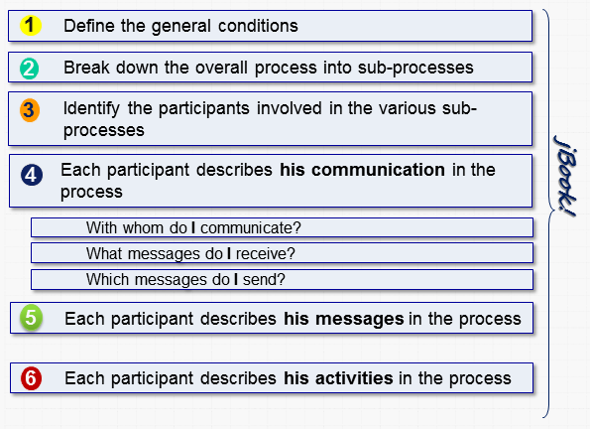

Figure 13.1: Activities of analysis

The first step is to define the general conditions for accomplishing tasks in the appropriate form (see Figure 13.2). This includes information such as name, objectives, tasks, success criteria, contribution to organizational success, and participants of the process. Furthermore, any risks are identified, described, and evaluated. These conditions should provide a brief overview of the position of an observed process in the organizational environment.



Figure 13.2: General conditions form of a process

The process objectives can be refined on the basis of an overview. jBook provides a separate template to this respect, in particular, to establish criteria to measure and evaluate the achievement of objectives (see Figure 13.3).



Figure 13.3: Form for detailing objectives

In the process map, it has already been specified that the process of applying for business trips poses no risk to the organization. Figure 13.4 shows a form designed to capture potential risks in detail.

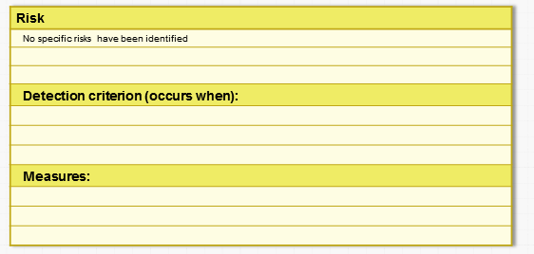

Figure 13.4: Form for detailing risks

Once the general conditions of the selected process are defined, the analyst can, in the second step, detail its structure. In this case, he splits the business trip handling into two sub-processes, the application process and the booking process, the latter of which is run at the travel agency.

Figure 13.5 shows the resulting structure and the messages exchanged between the subjects in the sub-processes, namely as a process network diagram (see Section 5.5.2).

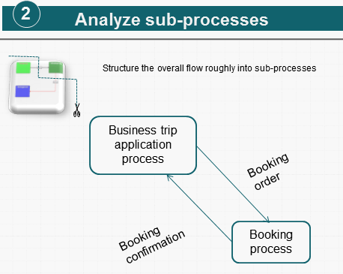

Figure 13.5: Sub-processes of the process ‘business trip application’

Based on the process structure, in a third analysis step the subjects of sub-processes need to be identified and their essential activities specified (see Figure 13.6).



Figure 13.6: Form for naming the subjects of sub-processes and identifying their main activities

In the next step, the analyst describes the communication between subjects. To do so, he collects and documents which messages a subject receives from others, or sends to others, respectively (see Figure 13.7).

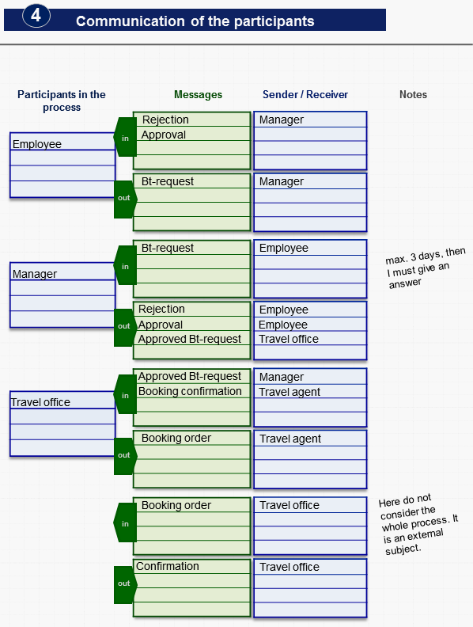

Figure 13.7: Form for documenting the communication between subjects

For a more detailed specification of the messages, jBOOK provides a template for parameters, as shown in Figure 13.8.

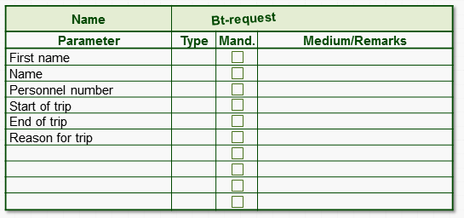

Figure 13.8: Form for defining messages and message parameters

The description of the communication between the involved parties can be included in the analysis, but this is not mandatory. It is advisable to include it, if at the time of the analysis the respective information is already available and can easily be complemented to the specification. The resulting documentation, however, will be complete only in exceptional cases. Therefore, traditionally, information about the message exchange and the parameters of the messages is added in the course of modeling, or even right from the beginning, first collected and described in detail there.

The same statement holds analogously for the sixth step of the analysis, the description of the subject activities. The analysis usually only leads to a rough outline that needs to be refined when modeling, i.e., describing the subject behavior. A typical basic behavior description for the subject ‘employee’ is shown in Figure 13.9.

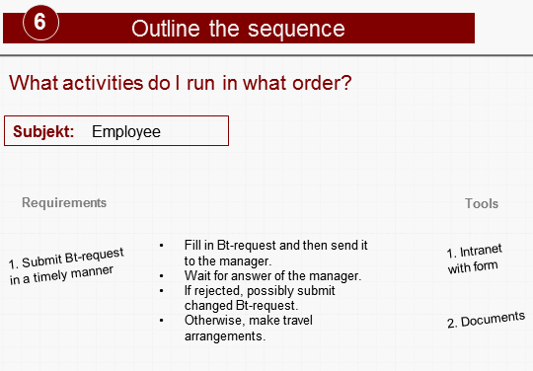

Figure 13.9: Form for describing a subject's behavior

13.3 Process Modeling

The results of subject-oriented analysis are complemented and accurately detailed in the context of modeling activities. In the following sections, we show how to use the module "Build" of the Metasonic Suite to enrich models with further details.

13.3.1 Process Overview

The starting point of modeling is the process map, which is based on step two of analysis. The tool allows the modeler to structure sub-processes in the form of process network diagrams (PND) (see Section 5.6.2). These shows how the sub-processes ‘business trip application’ and ‘booking’ are mutually related, and the possible interactions between the concerned subjects (see Figure 13.10).

The interactions in the overview do not yet need to correspond to individual messages. Thus, an interaction can be refined if needed into multiple messages in the communication view (see Section 13.3.2). In our example, this is not the case. The interactions between the processes consist of single messages, the booking order, and the booking confirmation, respectively.

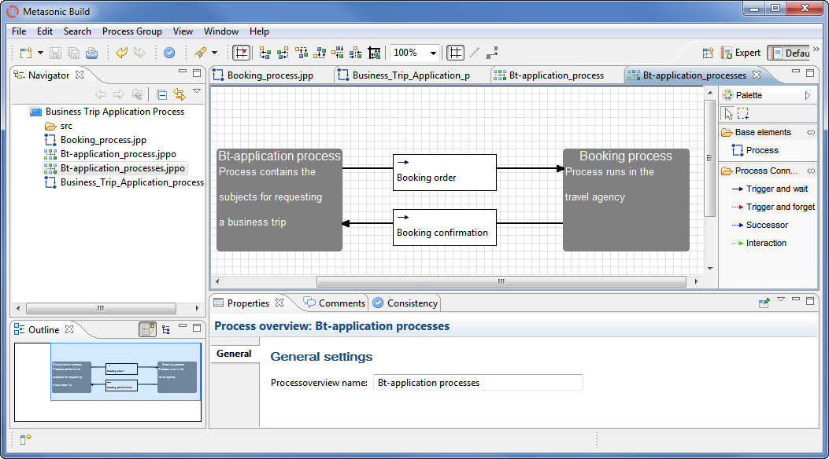

Figure 13.10: Process network diagram ‘business trip application process’

13.3.2 Communication View

The refinement of the process overview leads to the communication view, which is represented in the modeling phase by subject interaction and communication structure diagrams (SID, CSD) (see Section 5.5.3). As an input the modeler can use the information from the completed jBOOK templates gained in the analysis steps two, three, and four (see Section 13.2).

Figure 13.11 shows how the “Build” tool displays an interaction diagram containing the subjects of the process ‘business trip application’. The subject ‘travel office’ is an external subject, representing a corresponding interface as part of the process ‘booking' (see Chapter 5.6.2).



Figure 13.11: Subject interaction diagram of the sub-process ‘business trip application’

Figure 13.12 shows the process ‘booking’. From here, the external subject ‘travel office’, as an interface subject, refers to the process ‘business trip application’ in which it resides. The communication partner to the travel office in the process ‘booking’ is the internal subject ‘travel agent’.

Looking back again to the lower part of Figure 13.11, it can be noted that the interface subject ‘travel agent’ in the process ‘booking’ (*Properties* tab, *Link* (*relative)* selection list) is termed ‘travel agent’ (*Related Subject* selection list) rather than ‘travel agent’. This means that the interface subject and the corresponding internal subject (in this case, in the ‘booking’ process) need not be named identically.

For reasons of clarity however, identical identifiers are recommended, as with the travel office (see bottom part of Figure 13.12). However, in practice, this is not always possible, especially in cases in which the sub-processes are located in different organizations that need to be connected via interface subjects, and there are already historically defined names for organizational units or roles.



Figure 13.12: Subject interaction diagram of the sub-process ‘booking’

13.3.3 Subject Behavior

The next step in modeling is the definition of subject behaviors. The methodology provides the subject behavior diagram (SBD) for this purpose (see Section 5.5.5). Starting point is the data collected in step six of process analysis (see Section 13.2). Figure 13.13 shows the sample SBD for the subject ‘employee’ of the ‘business trip application’ process created using the modeling tool. Function states are characterized as rounded rectangles with a small clock icon, send and receive states with a small envelope icon with incoming or outgoing triangles, respectively. The transitions are specified using conventional rectangles with a horizontal arrow and a standardized verbal description.

This behavior reveals that the employee fills out the application form first, and then sends it via ‘provide business trip request’ to the manager. Then he waits for the response of his manager. This can be ‘approval’ or ‘rejection’. In the first case, the employee takes the trip, and then reaches the end state. In the case of ‘rejection’, the subject will immediately proceed to the end state.

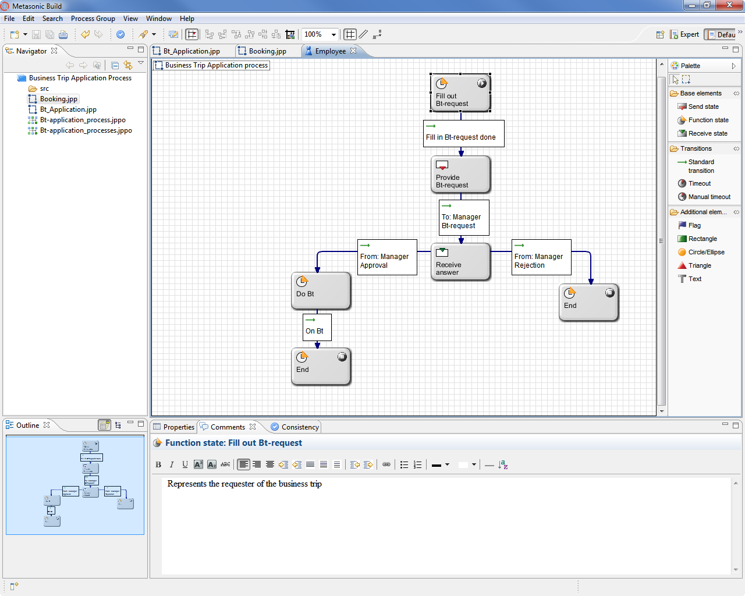

Figure 13.13: Behavior description of the subject ‘employee’

So far, we have considered only the logical flow of the process. However, the model specification can already be executed at this stage. This means that participants are able to test the business logic in a distributed role play. Before discussing this further in the context of the validation process described in Section 13.4, we explain the required data modeling activities. The modeler needs to specify what data exists in each subject state, and what messages transfer it between subjects.

The S-BPM method provides business objects for this purpose. They can be a complex structure, with different statuses, views, and access rights (see Section 5.5.7). For their manipulation, appealing user interfaces should exist (see Section 10.5.1.1). The functions provided by the modeling tool for the detailed definition of business objects are discussed in Section 13.6.

Here, we show instead how to quickly and easily define data, in order to test in the subsequent validation, whether they are even the right data, before refining their definition. Using this straightforward approach, complex business structures with object data types, plausibility rules for entry, etc., are not yet created, but rather simple data elements, which are initially sent as parameters using messages. The definition of such primitive business objects occurs on the level of business processes. The required information may stem from the jBOOK form for describing messages, completed in step four of the analysis (see Section 13.2).

Figure 13.14 shows the data (parameters) required for the process ‘business trip application’. Not all of this data is used in all subjects. However, each subject has its own set of variables for these parameters. Hence, a change of name in the subject ‘employee’ is not visible to the other subjects. Instead, the value of this variable ‘name’ needs to be transferred with a message containing the parameter ‘name’ to another subject that should know the value. When accepting the message, the value of this message parameter is transmitted to the variable ‘name’ of the receiving subject ‘manager’. Thus, the variable ‘name’ in the subjects ‘employee’ and ‘manager’ has the same content.

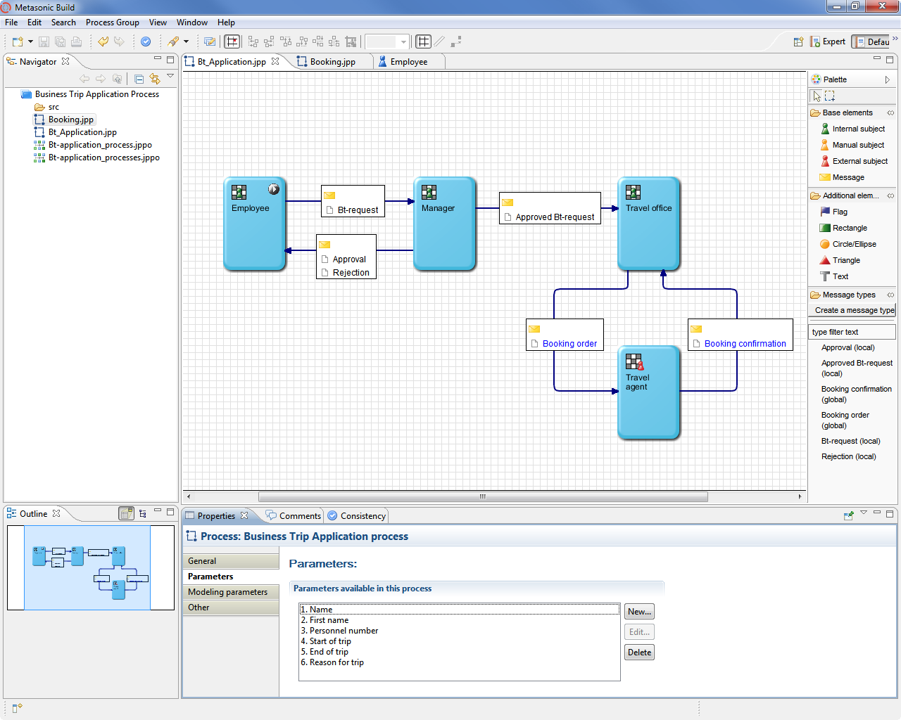

Figure 13.14: Modeling the data of the process ‘business trip application’

Each subject can potentially access all process parameters, which can be filled with values by internal functions in the subject behavior. Figure 13.15 shows this for the assignment of values ​​to the variables ‘name’, ‘first name’, ‘personnel number’, ‘start of trip’, ‘end of trip’, and ‘reason for trip’ in the function state ‘fill out business trip request’.

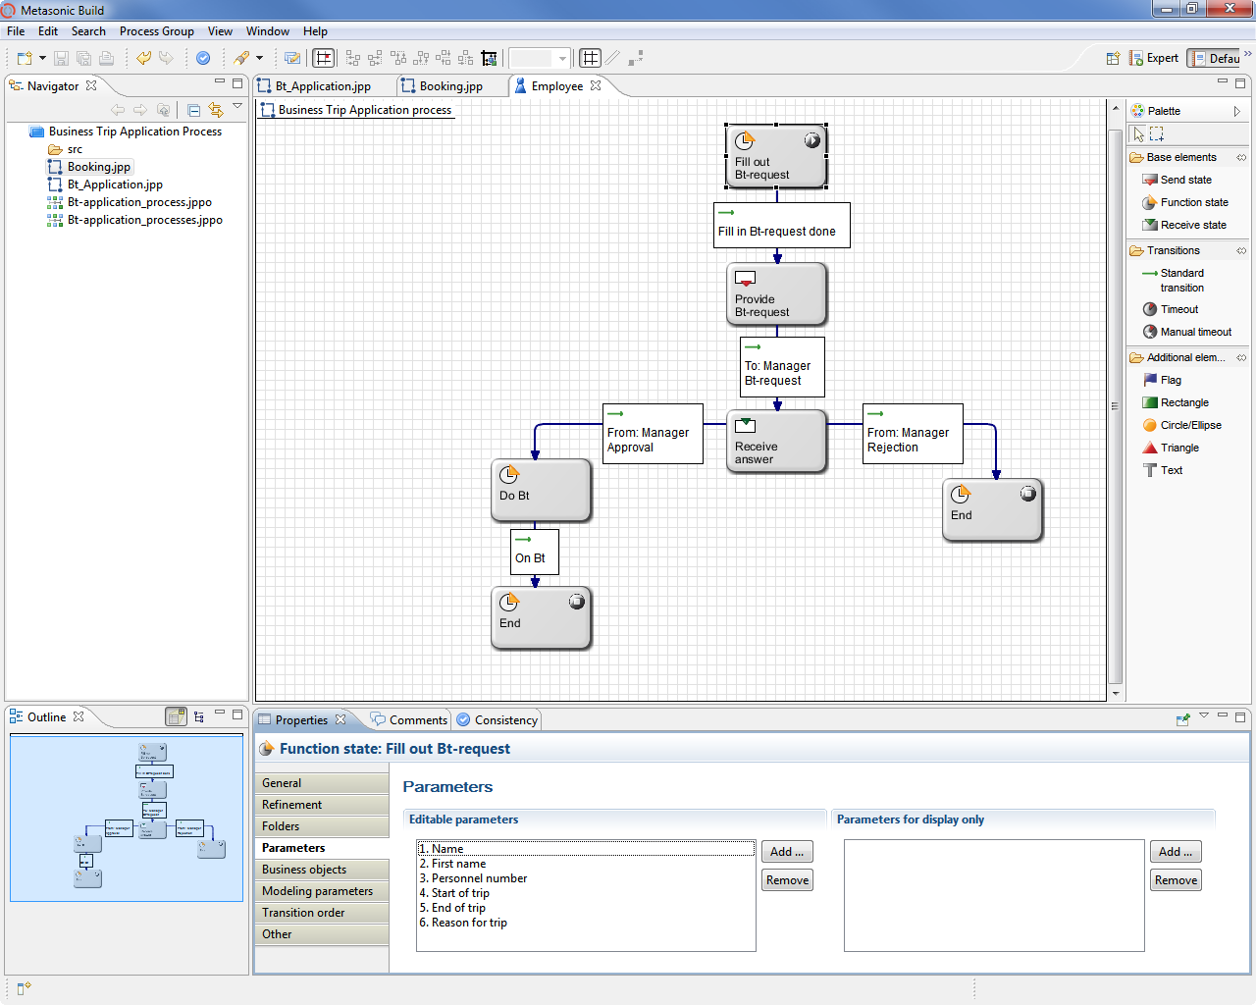

Figure 13.15: Parameter assignment in the internal function ‘fill out business trip request’

For the transmission of parameter values ​​between subjects, they need to be assigned to appropriate messages. Figure 13.16 shows this assignment for the message type ‘business trip request’, sent by the employee to his manager.

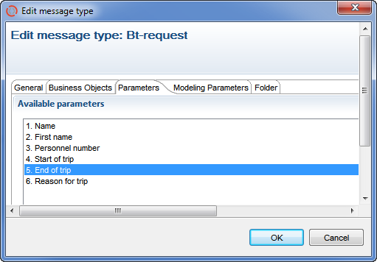

Figure 13.16: Modeling of the parameters of the message type ‘business trip request'

When receiving a message, the values are transferred from the message parameters to the subject’s local variables with the same name. Thus, the business trip request data is available after the receipt of the message ‘business trip request’ by the subject ‘manager’ for use in its internal checking function. Hereby, the data is delivered ​​by which the supervisor in his check function decides whether the transition to ‘reject’ or ‘approve’ will subsequently be executed (see Figure 13.17).

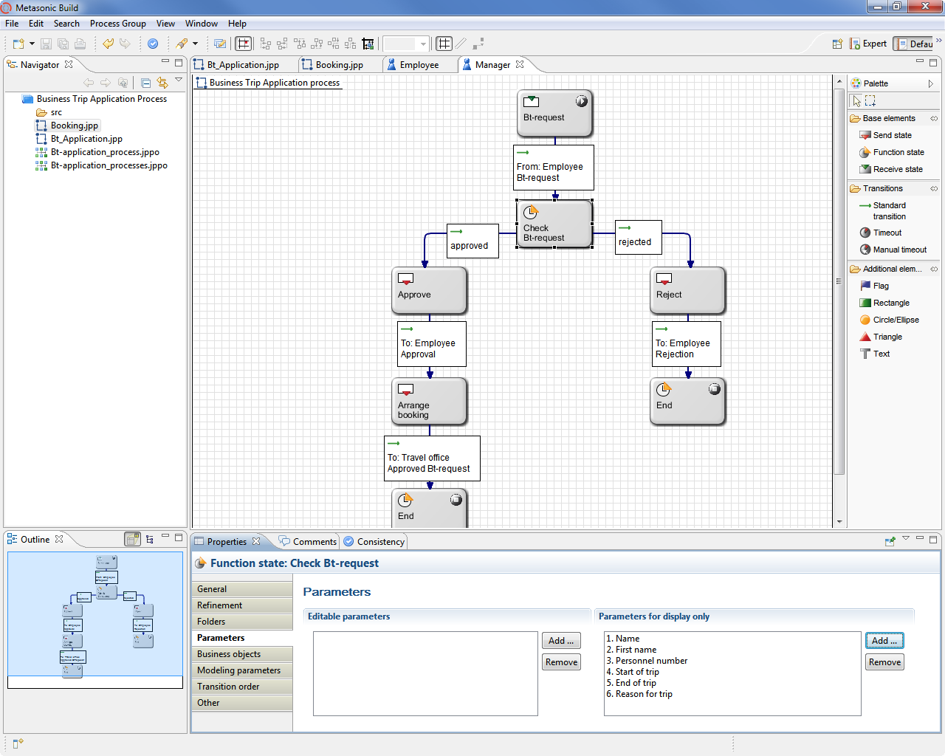

Figure 13.17: Modeling the receipt and use of parameter values

13.4 Process Validation

The process model contains in the current status all information regarding the logical flow of the process, the data required in the process, and the data variables either being used by the subjects or being exchanged between them by sending and receiving messages. Although the business objects are currently defined only in the previously introduced primitive form, i.e., without data types, value domains, origin of values, etc., the existing model can already be tested in a role play. This involves reviewing the following two questions:

* Does the described process logic correspond to the desired way of working?
* Do the data variables meet the process objectives?

For implementing an IT-based role-playing (see Section 7.5.2.2), the process model is transferred by the click of a button into the appropriate execution environment in the module “Proof” of the Metasonic Suite. This environment is available via Internet or Intranet, and can be accessed by a browser via its address (URL). Employees who are involved in a process can now use the subject, as it represents their share in the process: An employee applying for business trips uses the subject ‘employee’, a manager the subject ‘manager’, and an employee of the travel office the subject ‘travel office’.

These individuals can validate the process from their respective workstations. Each of them sees the behavior of the subject which he represents, and for which he will later be responsible in process execution. Each participant enters the necessary values of variables for his respective behavior states, i.e., works on the primitive form of business objects occurring in the process. By exchanging this information in accordance with the process flow, they quickly notice whether parameters for task accomplishment are missing, or redundant, etc. The participants can immediately overcome such deficiencies by using the “Build” module, then restarting the test environment “Proof” with the modified model, and examining the effects of the modification.

Figure 13.18 gives an overview of the control windows of the validation environment for the subject ‘employee’. The left window shows in which state the subject currently is (function state ‘fill out business trip request’). By clicking on the ‘parameter’ icon, the middle window will be displayed to enter values. In the example, this has already happened. Closing of the input leads to delivering the message ‘business trip request’ to the manager in the right window of the screenshot.

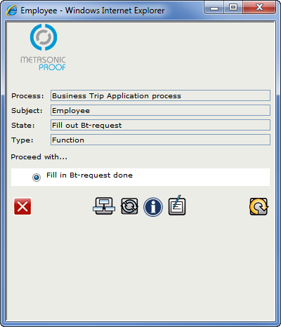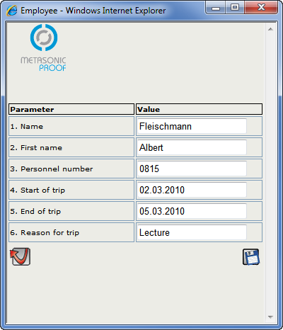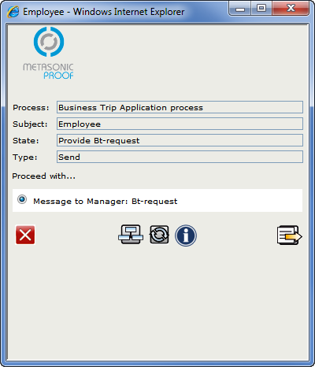

Figure 13.18: Validation user interface of the subject ‘employee’

Figure 13.19 shows the interactive window for the subject ‘manager’ indicating the receipt of a business trip request (left window). The manager accepts, by clicking on the icon with a right arrow, and changes from the receive state to the state ‘check business trip request’ of his behavior, where he can then decide between the options ‘approved’ or ‘rejected’ (middle window). For decision making, he can display the trip data by clicking on the parameter icon (right window).

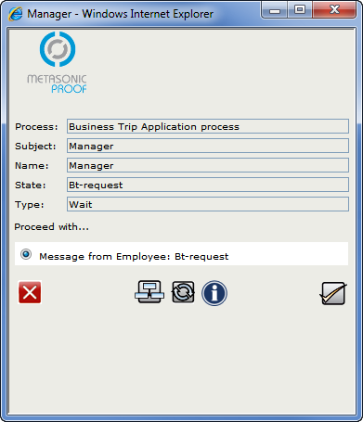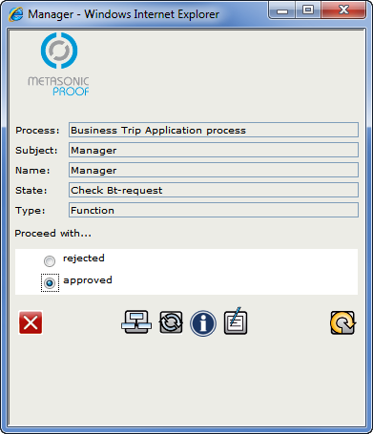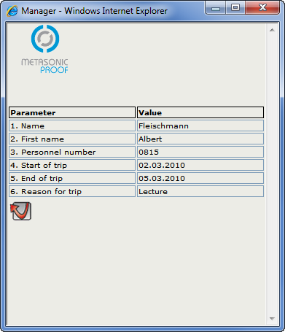

Figure 13.19: Validation user interface of the subject ‘manager’

An iteration in such a validation session corresponds to the execution of a process instance. A recorder documents each step of a validation session. The steps can be displayed in a swim lane diagram (see Figure 13.20).

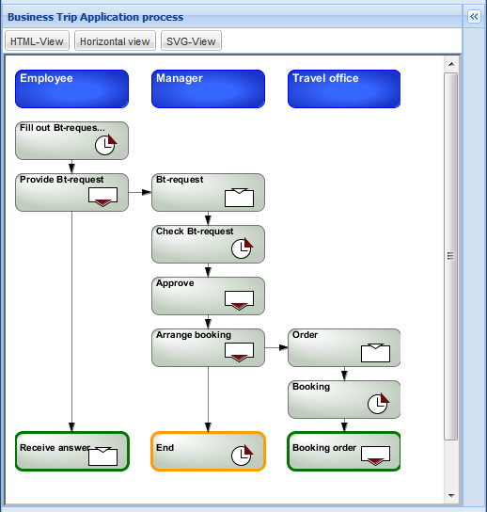

Figure 13.20: Swim lane protocol of one iteration of a validation session

In this way, an arbitrary number of validation sessions addressing different variants of process iterations for a process model can be performed, potentially with changing participants. This allows the parties to review whether the process corresponds to the desired way of working. Through the recording of the validation iterations, the test coverage can also be estimated.

13.5 Process Optimization

The validation checks whether the described process corresponds to the intended way of working, i.e., whether the right action is taken. Optimization is on the other hand about checking whether the validated process can be performed with minimal effort (see Section 8.2). For an associated simulation, it is necessary to determine, or at least estimate, the time required for each activity within a subject. In addition, it needs to be known how often per time unit a corresponding process instance is created and put into execution. Since such information is usually enriched with probabilities, the parameters for probability densities need to be known. Finally, resources need to be assigned to the subjects before starting a simulation run. Figure 13.21 shows the main screen of the jSIM tool for a subject-oriented simulation determining resource requirements and costs incurred in the execution of a process.

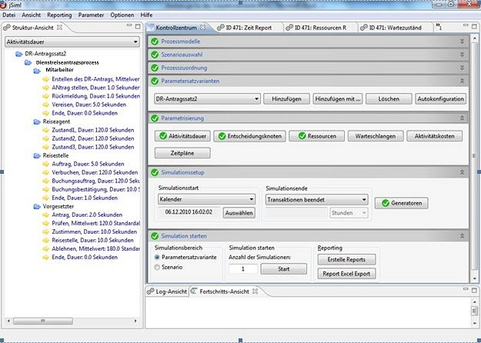

Figure 13.21: Main screen for entering simulation parameters

In Figure 13.22, the times required for the accomplishment of individual actions in the respective subjects are shown. Thus, the duration of creating the business trip request is distributed normally with an expected value of 180 seconds and a standard deviation of 40 seconds. For reasons of simplicity, in this example the other time parameters are assumed to be constant.

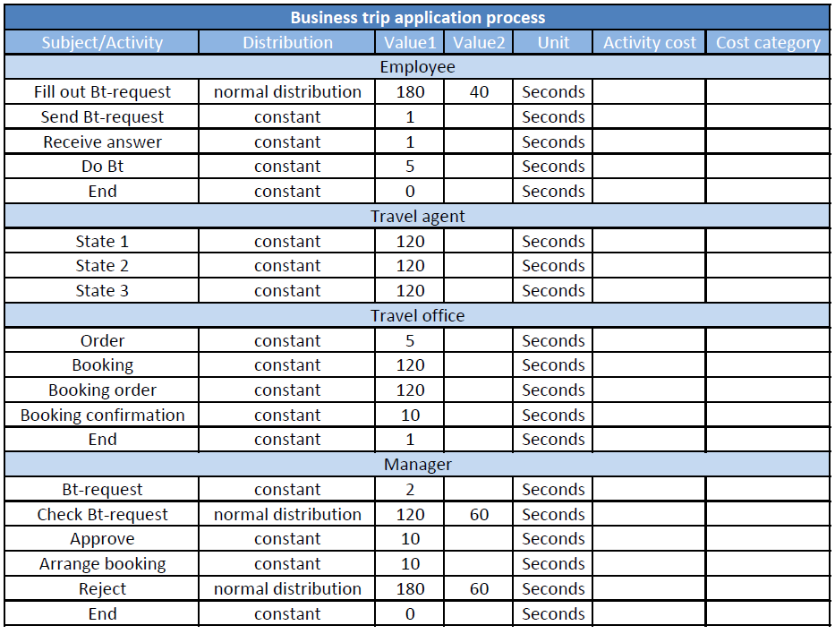

Figure 13.22: Excerpt of simulation parameters

It becomes apparent that the determination of the parameters for the simulation is not trivial and requires extensive experience. Even after this hurdle has been taken, the interpretation of simulation results requires advanced skills. In Figure 13.23, an excerpt of the simulation results is presented. The graph shows the minimum and maximum activity and waiting time, and the minimum and maximum resource requirements for a given instantiation of processes.

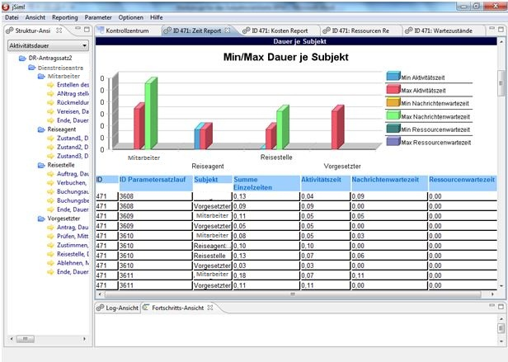

Figure 13.23: Excerpt of simulation results

13.6 Modeling Business Objects and Integrating in Behavior Descriptions

So far, only simple parameters have been used as business objects in process models. They merely served to verify in validation that all required data was included in the model.

In Section 13.3.3, we have already mentioned that business objects occurring in a process subsequently require a more detailed and precise modeling specification in order to comply with the requirements of a workflow system being used in practice. This detailed description includes aspects that we have presented in Section 5.5.7. Examples here are hierarchical structuring; the definition of states, views including access rights, look-and-feel, value ranges ​​for user input; and the coupling of programs to manipulate data elements.

In the following, we show an excerpt of the potential tool support for detailed modeling of business objects in terms of their subsequent use when executing the process in a workflow engine. The result of this detailed modeling of business objects can also be tested in the validation environment, before implementing a process in a workflow.

Figure 13.24 shows the structure of the business object ‘business trip request’ and its defined views. The application consists of three parts: ‘personal data’, ‘information on the business trip’, and ‘processing status’. Each of these three sections contains respective elements. The modeler can therefore organize a business object with the tool across various hierarchy levels, in each of which data structures and / or individual data elements can occur. For each element, different attributes can be specified, e.g., whether an element could occur multiple times (like a position of an order), whether it is a mandatory field users need to fill in, its specific data type, etc.

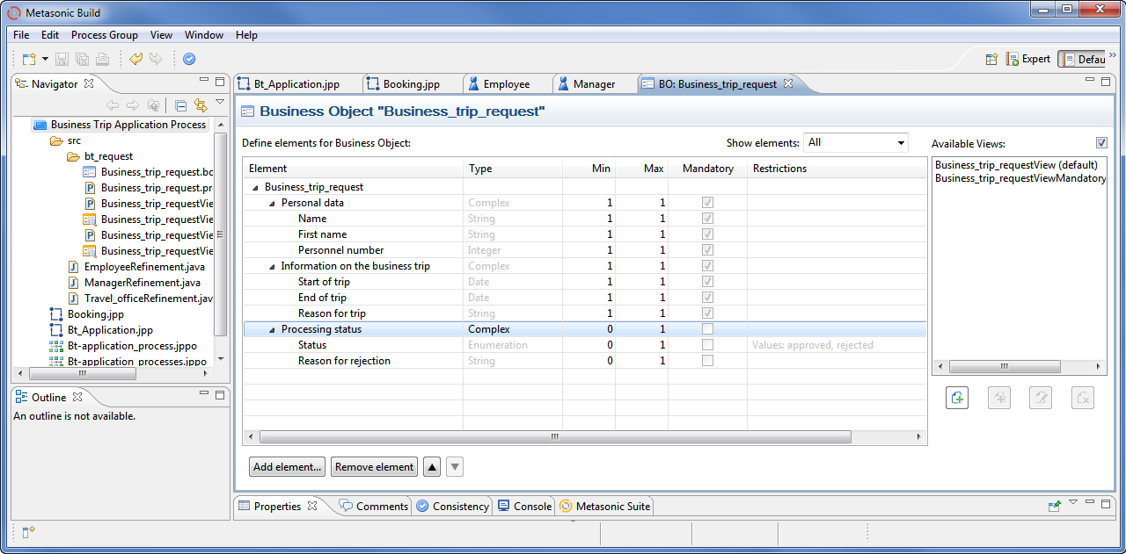

Figure 13.24: Business object definition using the business object editor

For each business object, any number of views can be specified, each containing subsets of the elements of the object. In this way, the modeler can determine that during execution only an excerpt of a business object is displayed, processed, or transmitted in specific states. Figure 13.25 shows the view ‘no decision’ on the business object ‘business trip request’, which contains only the personal data and the information on the business trip. The processing status containing the approval notice is not displayed in this view.

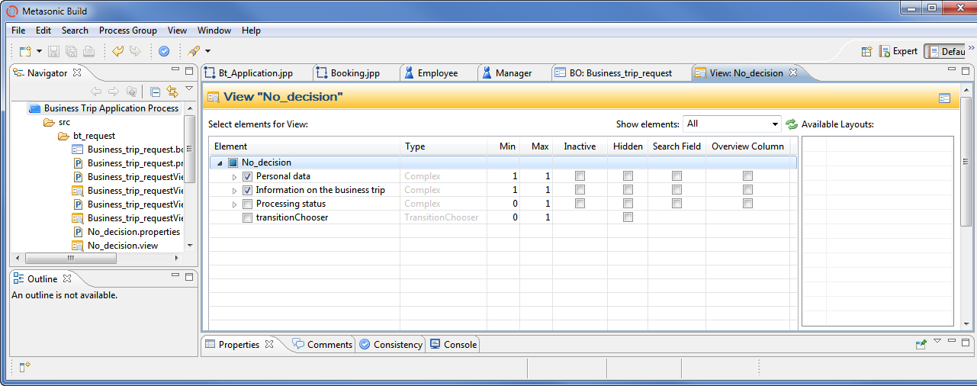

Figure 13.25: Specification of a view using the business object editor

After having defined the structure, views, and rules (not illustrated), it has to be determined how the business object is to be displayed on the screen. Figure 13.26 shows the editor for specifying the layout.

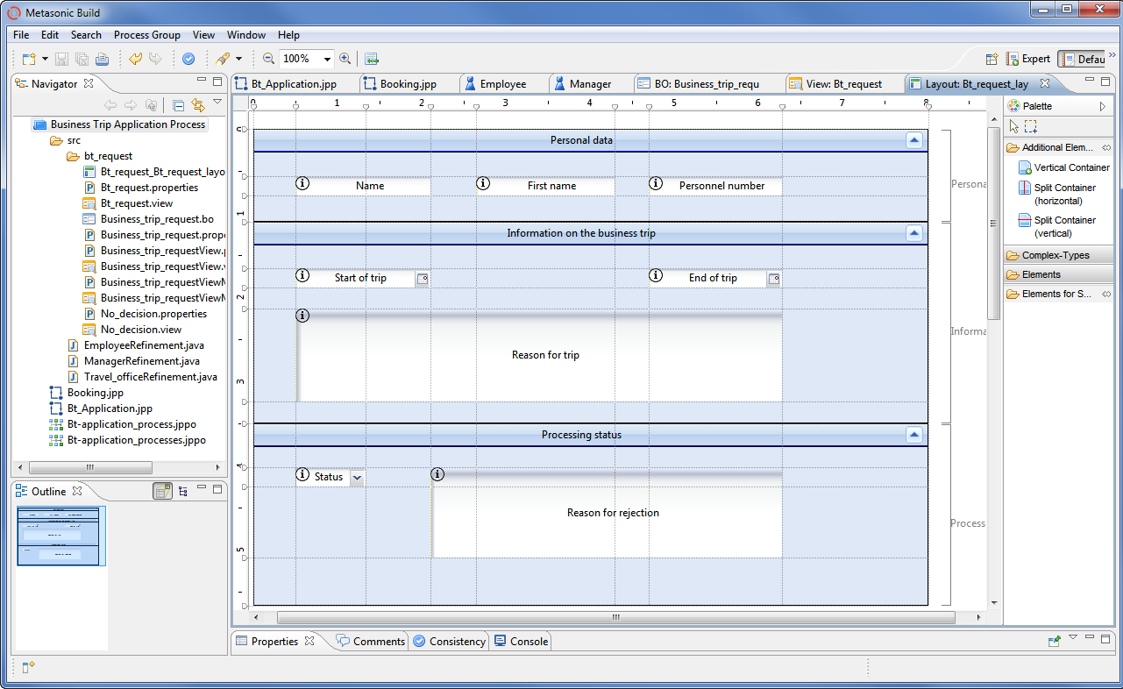

Figure 13.26: Specification of a form using the business object editor

After completing their definition, business objects need to be inserted at appropriate positions into the behavior description of a process. To do so, the user selects in the modeling tool the state in which the business object is used, e.g., displayed and / or filled out. For this purpose, there are so-called folders. In each state, it is defined what business object types are allowed in a specific folder, and what types of operations can be executed in this state.

Figure 13.27 shows this information for the state ‘fill out business trip request’, in which the ‘business trip request’ can be created, displayed, and edited.

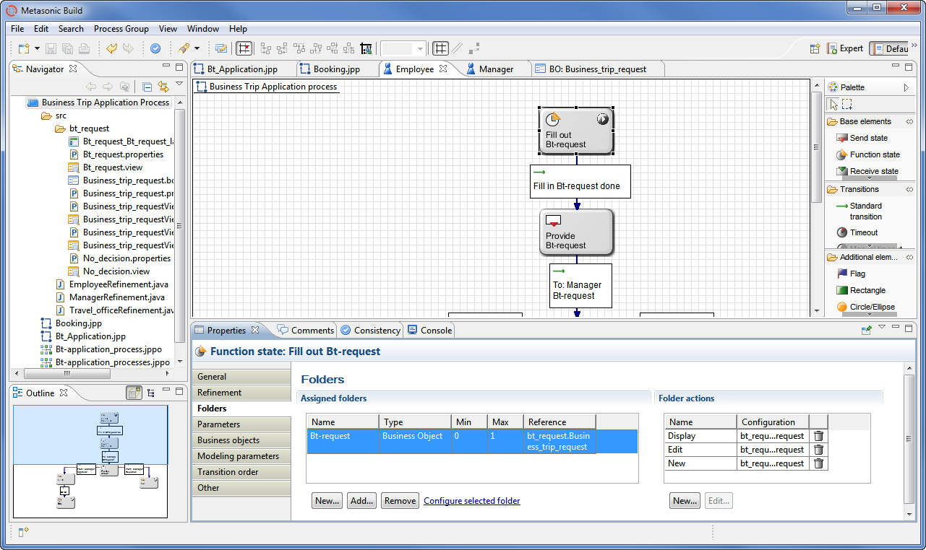

Figure 13.27: Integration of the business object ‘business trip request’ in the state ‘fill out business trip request’ as part of the behavior specification of the employee.

13.7 Organization-specific Implementation

After describing the process behavior and the business objects, an active agent (subject carrier) needs to be assigned to each subject. This carrier performs the actions of the subject according to the modeled behavior (see Chapter 9).

The assignment of an active agent to a subject is performed using the tool “Usermanager” on several levels. A person (subject carrier) is part of one or more groups (subject carrier groups). One or more of these groups are assigned to a role, and a role to one or more subjects.

Figure 13.28 shows how Mr. Schulz is assigned to the group ‘employee group’ using the “Usermanager”.

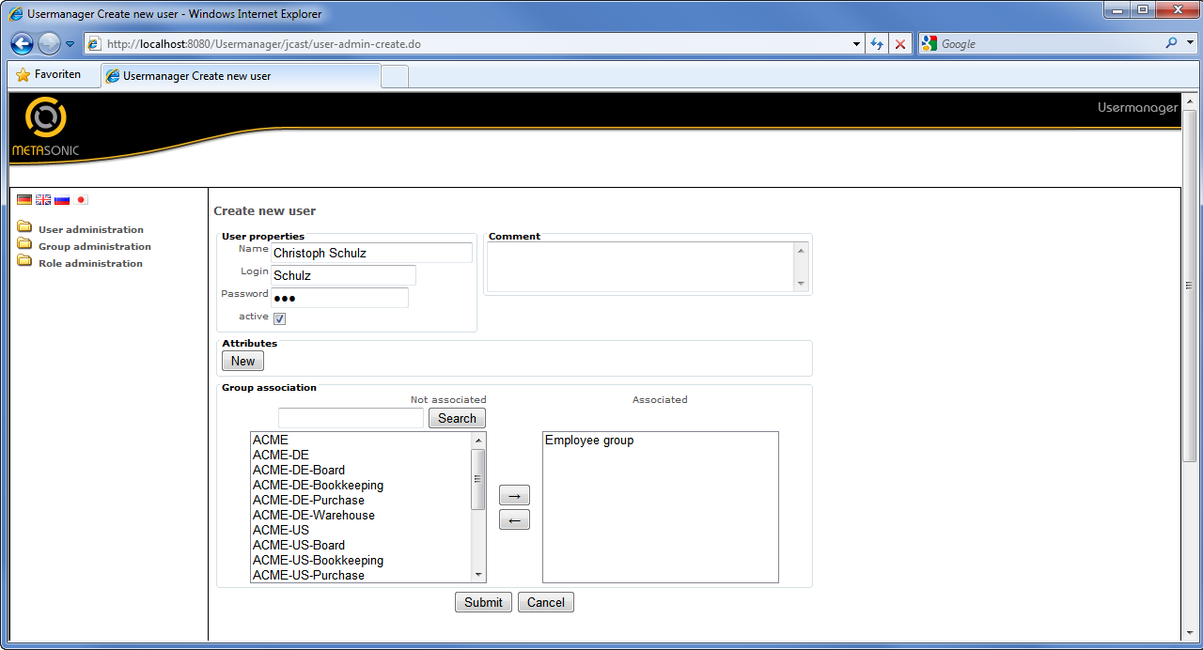

Figure 13.28: Screenshot of the tool for managing users, groups, and roles

Analogous to the assignment of Mr. Schulz to a group, a role is assigned to a group. The assignment of roles to subjects is performed using the modeling tool. Figure 13.29 shows how the role ‘employee’ is assigned to the subject ‘employee’.

At the end of the outlined multiple steps, Mr. Schulz is able to submit a business trip request, since he has been assigned to the subject ‘employee’ as subject carrier.

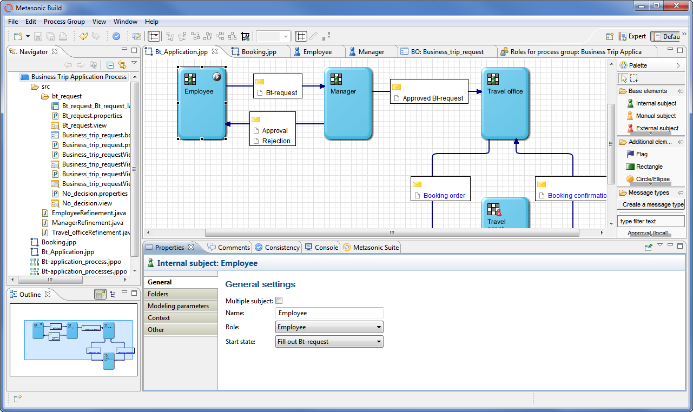

Figure 13.29: Assignment of a role to a subject using the modeling tool

13.8 IT-specific Implementation

After embedding a process in the organization, the integration of applications needs to be performed. Applications are used to retrieve business object content, to manipulate it, to store it, etc. (see Section 10.5.1).

The integration is realized by so-called refinements. They denote software invoked in function states within the subject behavior. Whenever a process enters a state with a refinement, the stored program is executed. Such a program may initially serve only to call an existing application having a specific user interface for editing a business object (e.g., an SAP transaction). A refinement could also be code which itself accesses business object content, and manipulates it in a dialog with the user.

Figure 13.30 shows the storing of a refinement in the state ‘check business trip request’. The implementer uses the option ‘Execute own refinement’ to insert a specific refinement to this state.

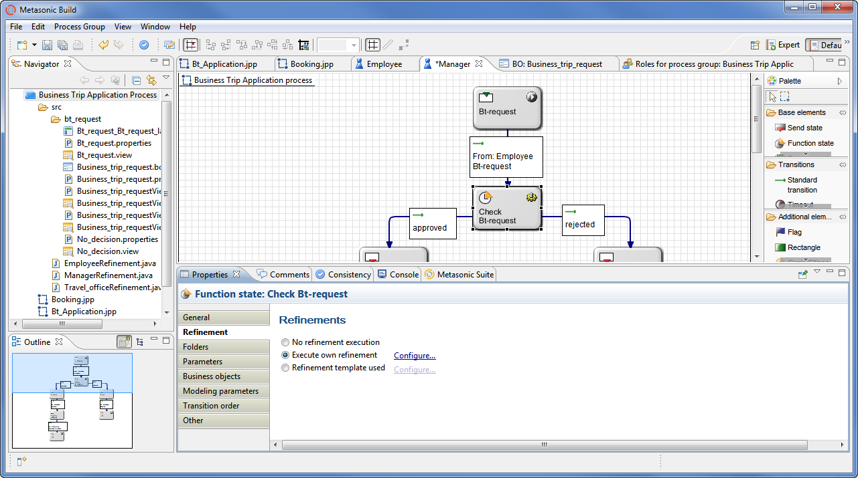

Figure 13.30: Insert ‘Execute own refinement’

Figure 13.31 shows the respective potential code body.

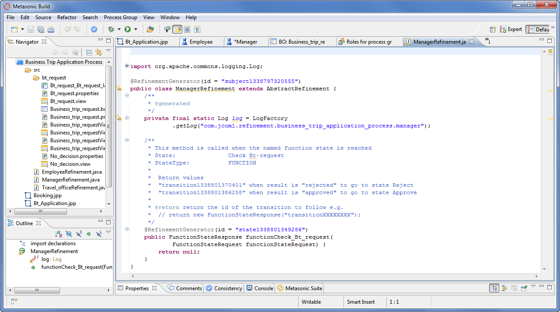

Figure 13.31: Body of code for a refinement method

13.9 Process Execution

Once the applications running in a process have been integrated, the process can be used productively after extensive testing.

A suitable workflow engine, in our case, the module “Flow” from the Metasonic Suite, interprets the structured process model at runtime and controls the operations from its instantiation to its termination. The engine ensures that the subject carriers perform those actions in each processing step that are expected of them according to the behavioral description of their assigned subjects (internal function, send, receive). At the designated positions in the model, the engine supplies them with the business objects to be processed and invokes the designated applications.

For instance, Mr. Schulz could log on to the workflow system and create a process instance for applying for a business trip. Figure 13.32 shows the workflow system in the initial state in which the employee submits the request. In the upper part, the respective state of the process is displayed to the user, and in the lower part the business object to be filled out.

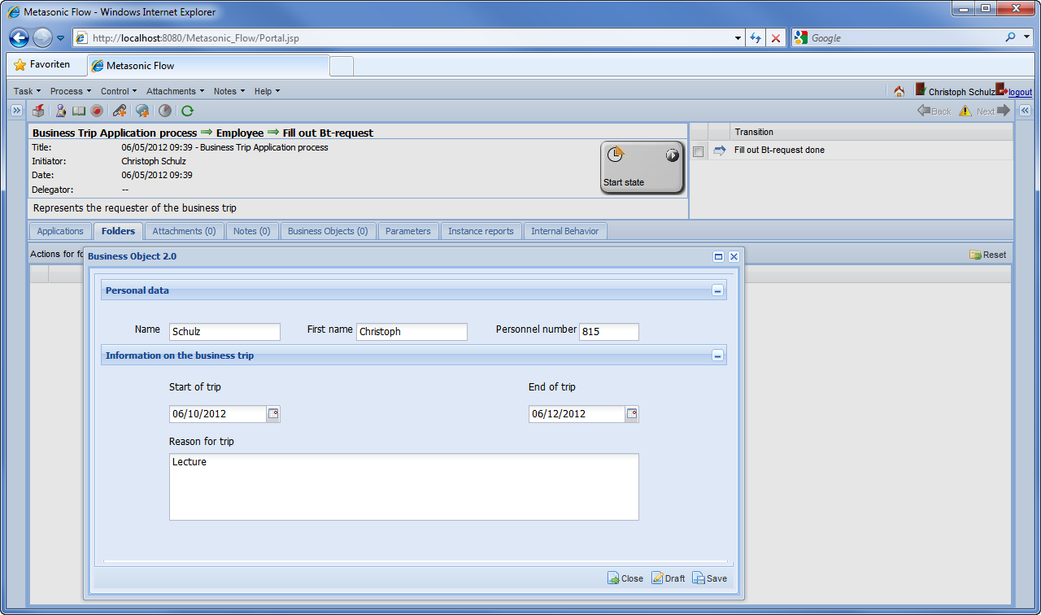

Figure 13.32: The workflow system in the state ‘fill out business trip request’ of the subject ‘employee’

After filling out the business object, the user triggers the transition to the next state (top right). After that, the business trip request of Mr. Schulz is transmitted by an appropriate interaction to his manager Mr. Schmid. Mr. Schmid accepts the message with the request and checks it. Figure 13.33 shows the corresponding user interaction.

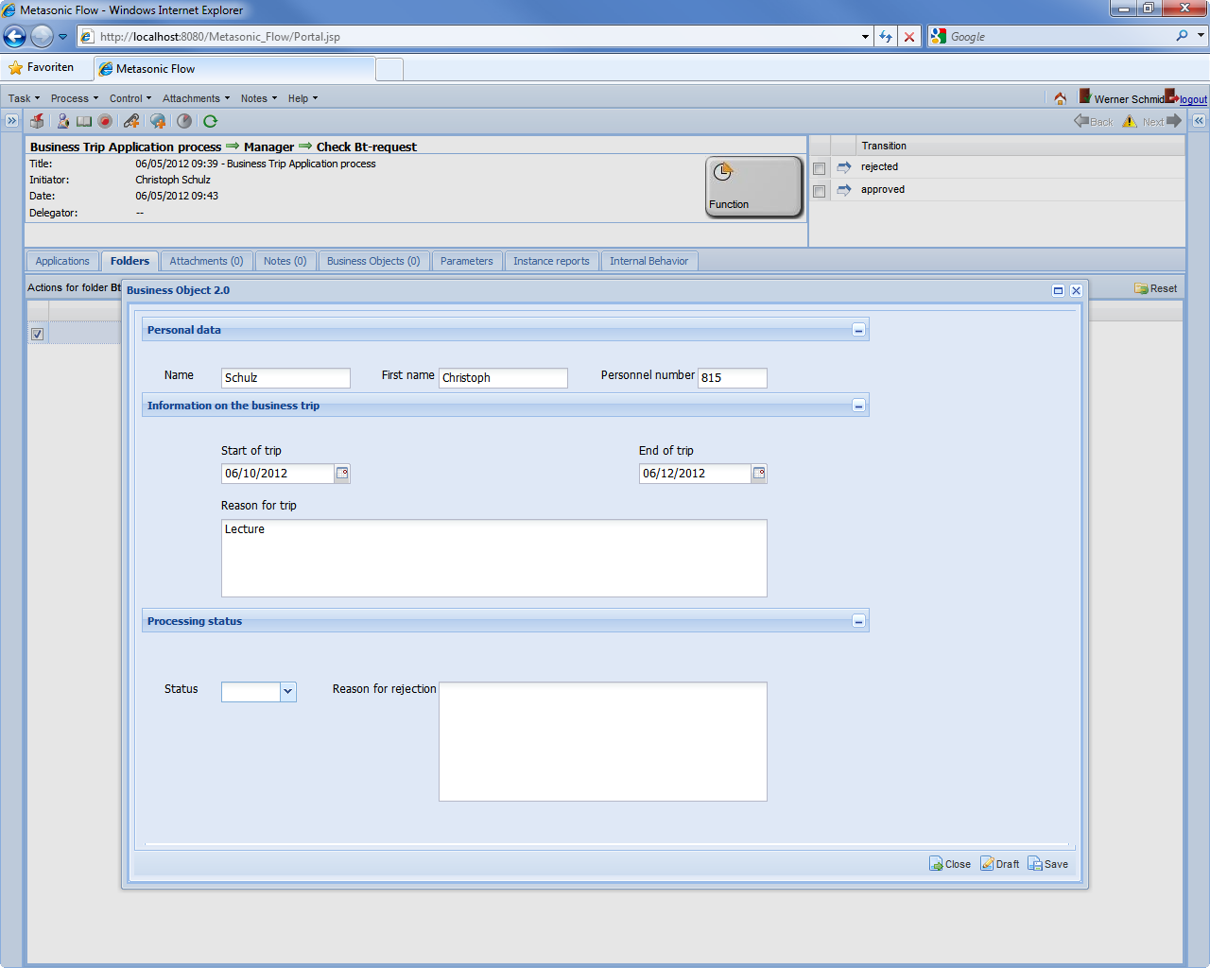

Figure 13.33: The workflow system in the state ‘check business trip request’ of the subject ‘manager’

13.10 Process Monitoring

During execution of each process instance, the workflow engine records numerous data. Examples include the state for each process instance, the point in time at which this state is reached, and much more. Such data about instances can be used to observe process executions in an organization (see Chapter 11). Executives can, for example, receive information about how many crucial process instances are currently being executed, or how each process progresses in each process instance.

Figure 13.34 exemplifies a simple list including details of running process instances. It contains the name of the process, its priority, the name of the person who created the instance, the time stamp when it was created, etc. The table includes only a small part of the recorded, and therefore available, data.

Such a list representation of the processes running in an organization can quickly become overloaded once further parameters are included. Then, it can become necessary to implement a process cockpit with intelligible indicators and traffic light representations (see Section 11.6).

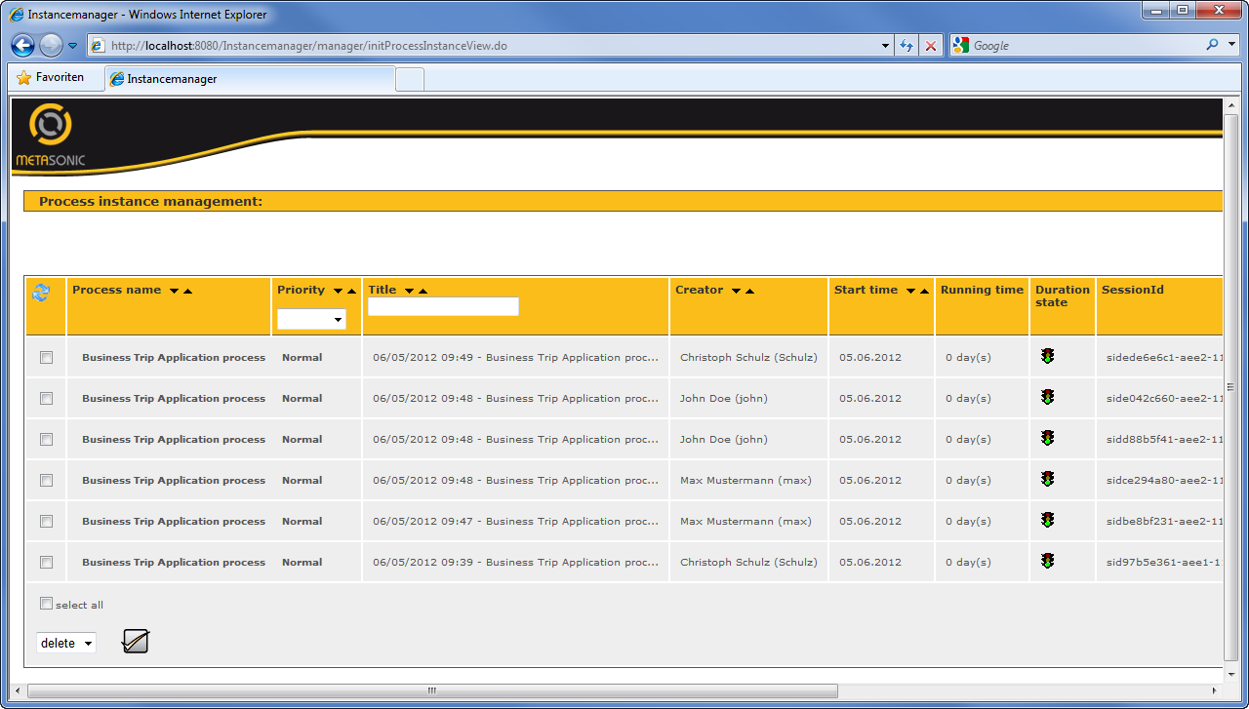

Figure 13.34: List of process instances in the monitoring tool